ANNUAL REPORT 2017/18

2017 was another successful year for the club with membership continuing to grow and approaching the 400 mark. We celebrated the many outstanding performances and the hard work put in by all our members at our Annual Awards Night in November which was held once again (indoors!) at Alfresco on the seafront. Awards recognised effort and commitment to the club as well as outstanding performance.
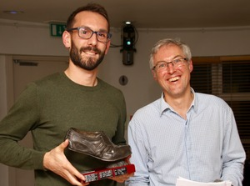
http://www.brightonphoenix.org.uk/stories/602
http://www.brightonphoenix.org.uk/stories/601

We pride ourselves on bringing together athletes of all levels at the club - as reflected in the three hours or so between the first and last of our gutsy 24-strong contingent crossing the finishing line at the 2017 Brighton Marathon! And the enthusiasm of our under-11 cross-country and Sportshall teams is matched by our small but dedicated band of over-60 and over-70 athletes who have continued their impressive accumulation of trophies. To avoid sounding too much like a recital of a school register the namechecks in this report are mainly those of our quicker athletes, but this is not meant to devalue all the fine performances from other club members. You can find their names recorded if you follow the links to the relevant news stories on our website, or by going to our Results page for 2017 http://www.brightonphoenix.org.uk/results/archive/2017 or the current Results page http://www.brightonphoenix.org.uk/results and scrolling down to the relevant event. The Results pages also contain details of extra events not listed in this report. Our women athletes in particular had an outstanding year, both in terms of individual honours right up to national level but also in terms of improved strength in depth reflected in terms of success for our women’s and girls’ teams in all areas from Sportshall to cross-country and the Sussex Grand Prix Sports. The one area where there remains clear room for improvement is at junior level where we still want to see more of the large numbers of younger members we cater for at training sessions competing more regularly.

PHOENIX FAR AND WIDE

Our flashmob Parkrun tourism has continued to attract a good following; so far we have only ventured out within the Sussex boundaries – for instance a trip last July to the newly-established and very scenic Peacehaven parkrun http://www.brightonphoenix.org.uk/stories/574

Individual Phoenix athletes have travelled much further afield. To mention just a few:
Hannah Carey toughed it out at the ultra-hilly Meltham 10k in West Yorkshire in January http://www.brightonphoenix.org.uk/stories/541.

Kevin Bramhill travelled to Wales for the notorious Man v Horse race and ran a good race leaving 14 horses in his wake http://www.brightonphoenix.org.uk/stories/567.

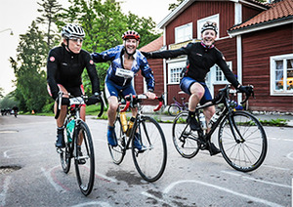

Andy Bone Mike Townley and Anita Jones were amongst 22,000 other cyclists as they sped round the 300k Vatternrunden race in Sweden in just nine and a half hours http://www.brightonphoenix.org.uk/stories/569.

A herd of curious cows and calves formed the bulk of the spectating crowd as Kate Gorman and Paul Weir triumphed at our annual Blackcap Handicap out on the Downs last June. http://www.brightonphoenix.org.uk/stories/568

Our triathletes travelled all over Europe and further afield in search of pain and gain – see Multisport section below.
Andy Neighbour headed to Ireland for the Causeway Coast Half Marathon, which afforded him two hours of clambering over seaweed-covered rocks, stretches of beach running and of course close-up views of the Giants Causeway. http://www.brightonphoenix.org.uk/stories/598

Donald Maclellan scaled his usual quota of Celtic mountains in the Ben Kenneth Hill Race, the Snowdon International Mountain Race, and on his home patch for the comparatively flat Harris Half Marathon.

Other adventurous trips have included the Copenhagen Marathon (Barry Blackwell), Amsterdam Marathon (Ray Matthews and Amelia Culshaw), Prague Half Marathon (Phil Hampshire) and Hadrian’s Wall Ultra (Andy Pumphrey)

CROSS-COUNTRY

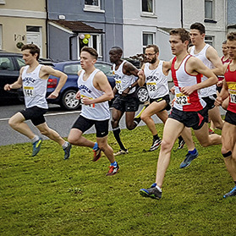
At the Sussex Cross-Country Championships at Bexhill on 7th January 2017 we collected a sizeable haul of individual medals with silver for Lukas Nerurkar (U13 Boys), Alice Wright (U13 Girls) Tara Bage (U20 Women) and Billy White (U20 Men), and gold for Leo Brewer (U15 Boys), Almi Nerurkar (U17 Girls), Dan Stidder (U20 Men) and Jon Pepper (Senior) Men. Despite a disappointingly low turnout of just 19 juniors and 19 seniors across all categories we did also collect a couple of team medals – gold for the U17 girls and bronze for the Senior Men.
http://www.brightonphoenix.org.uk/stories/537

A week later Almi Nerurkar and Dan Stidder repeated their winning U17/U20 performances U17/U20 at the Sussex Schools’ Championships on 18th January, with Maia Hardman also claiming U17 bronze. And the following month Dan went on to add the South East Schools’ U20 title to his collection.
http://www.brightonphoenix.org.uk/stories/539

We had a good turnout of 30 runners at the 2017 Sussex Masters Championships at Lancing on 21st January. Paul Whelpton, who claimed silver in the V60 category, was our only individual medallist, and our only team medals went to our V40 men who finished in third place.
http://www.brightonphoenix.org.uk/stories/540

We sent a small contingent to the South of England Championships at Parliament Hill on 28th January; our highest placed runners were Jon Pepper (13th in the Senior Men’s race), Leo Brewer (17th in U15 Boys) and Naomi Fonteyn (40th U17 Girls)

The 2016/17 Sussex Cross-Country League season ended with the final race run over a shortened course at a waterlogged Hickstead on 11th February. In the final placings we won four team medals, silver for our U15 Girls and bronze for our U17 Girls and Senior Men, and a particularly impressive bronze for our Senior Women in their first year since winning promotion to Division 1 of the competition. There were also individual gold medals for Tara Bage (U20), Ben Matthews (U20 and Paul Whelpton (V60), silver for Alice Wright (U15) and Bronze for Naomi Fonteyn (U17) and Dave Carter (V40)
http://www.brightonphoenix.org.uk/stories/544

The highlight of the 2016/17 cross-country season was probably an unexpected one, the Welsh National Cross-Country Championships in February 2017, where Beth Kidger had an emphatic win by almost 20 seconds in the Senior Women's race over a 6.4k course to become Welsh National Champion. So for once the English National Champs on the same day failed to make centrestage, despite notable performances from Jon Pepper (40th in Senior Men’s race) and Tara Bage (38th in Junior Women’s race).

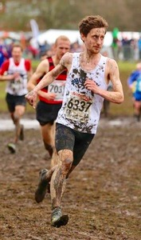

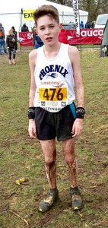
The following 2017/18 Sussex cross-country season began as usual with the Goodwood Relays on 1st October, where our V50 men did particularly well to finish in 2nd place. Turnout was inconsistent at the four league races, though twenty or more of our senior men regularly made the startline. After the final race at Stanmer Park on 11th February our U15 Girls and Vet Men finished in silver medal position and our Senior Men claimed bronze. Alice Wright won individual bronze and it was Senior Men silver for Max Dumbrell and V40 silver for Dave Carter.

Ben Connolly, Will Carey, Alice Wright, Naomi Fonteyn and Almi Nerurkar all did well enough in the Sussex league races to earn themselves Sussex vests for the South of England Intercounties Championship at Horspath on 9th December 2017. Almi came away with another gold medal in the U17 Girls race.
http://www.brightonphoenix.org.uk/stories/607

The 2017 South of England Masters Championships took place at Horspath on the same day, and despite all but two of our Vets shunning the event there was more gold for Phoenix as (to his amazement) Paul Whelpton ran away from a high-class field to claim the V65 title by a winning margin of over three minutes.
http://www.brightonphoenix.org.uk/stories/610

Fifty of our runners (good but still room for improvement!) turned out for the 2018 Sussex Cross-Country Championships at Bexhill on 6th January. Our U15 Girls finished in tantalising 4th place and there were bronze medals for our U17 Boys and gold for our U20 and Senior Men. Almi Nerurkar (U17 Girls), Dan Stidder (U20 Men) and Ross Skelton (Senior Men) claimed individual gold, silver and bronze in their respective races.
http://www.brightonphoenix.org.uk/stories/612

The 2018 Sussex Masters Championships took place at Lancing on 20th January in spectacularly muddy conditions. A good turnout saw Paul Whelpton and Dave Carter came individual gold as they led their respective teams to V60 bronze and V40 gold.
http://www.brightonphoenix.org.uk/stories/616

Fifty of our runners also made the South of England Championships on 27th January which returned this year to Stanmer Park. Congratulations are due to everyone who ploughed round to the finish in very challenging conditions (We love mud!). Almi Nerurkar made light of the conditions and raced to second place in the U17 Girls’ event.
http://www.brightonphoenix.org.uk/stories/617

ROAD AND TRAIL RUNNING

Excellent win for Finn McNally in the Chichester 10k on 5th February 2017 in 30:46.
http://www.brightonphoenix.org.uk/stories/543
Later that month Finn lined up alongside three more of our elite athletes - Max Pickard, Max Dumbrell and Sam Wade - at the prestigious Armagh 5k and our quartet finished in an impressive sixth place. Also in February Paul Whelpton’s 1:24:07 at Hampton Court took him to the top of the National V60 Half Marathon rankings.
http://www.brightonphoenix.org.uk/stories/546
A week later 19 Phoenix runners completed in the Brighton Half Marathon, with Alex Cruttenden our highest finisher. In the accompanying youth races 23 of our youngsters competed with eight of them making it on to the podium.
http://www.brightonphoenix.org.uk/stories/551

March saw impressive wins for Jon Pepper in the Steyning Stinger, Paul Weir and Jonny McCormack in the Moyleman Relay, and Alex Cruttenden in the Beachy Head Half Marathon.

April 2017 began with the Sussex Road Races, always one of the highlights of the year. A Phoenix team led by Bruce Warren, Ruth Mansfield and Steve Hardman took on the organising of the event, and their efficiency was matched by our athletes. Our Senior Men came within a whisker of repeating their unprecedented 1-2 finish of the previous year, claiming 1st and 3rd places, whilst our U15 girls claimed silver and V60 Men bronze. Performance of the day came from our Senior Women’s trio - Beth Kidger, Naomi Fonteyn and Sophie Mansfield - who came away with the gold. Fastest laps of the day were posted by Beth and (naturally) Charlie Grice.
http://www.brightonphoenix.org.uk/stories/558

Jon Pepper’s determined frontrunning saw him out on his own in the lead for much of the way in the Brighton Marathon, though he slipped to 3rd in the later stages of the race. His 2:31.51, though way off his best, still put him very comfortably ahead of our other 23 runners, though Darryl Hards (at training pace in preparation for a 100k race!), Alex Bonzi and Matt Greenall all made it home inside the 3-hour mark.
http://www.brightonphoenix.org.uk/stories/560

At the London marathon our top finisher was Joe Butler, whose impressive 2:52 finish was only good enough for 1000th place in the giant field!

May saw Darryl Hards, wearing an England vest, help the national team to victory in the Anglo-Celtic Plate over the gruelling 100k distance; and Robbie Fitzgibbon finishing 2nd in the National Mile Championships at Westminster, his time of 4:05 proving good enough for him to end 2017 at the top of the U23 National Rankings.

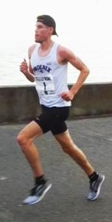
Our own Phoenix 10k in July again doubled as the Sussex County 10k Championships and saw Finn McNally finish a close 2nd to a London runner and thus claim the Sussex 10k title. There were also Sussex titles for Malcolm Kemp and Paul Whelpton in the V70 and V60 categories, and 3rd place for our men’s team - Finn, Sam Wade and Sean Parker-Harding.
http://www.brightonphoenix.org.uk/stories/571

Also in July there was a notable triple success at Eastbourne where Ross Skelton’s victories in the Senior Mile and 5k races Mile were almost matched by Eddie Harrison, whose 5:57 earned him 2nd place in the Junior Mile.

In August Paul Whelpton’s 1:24:57 at the Gloucester City Half Marathon proved good enough to see him finish top of the 2017 national V65 rankings.
http://www.brightonphoenix.org.uk/stories/579

Finn McNally chalked up another win at the Kings Head Canter 5k on 28th August, where his winning time of 15:06 was a new course record. Combined with his win at Chichester, and the Sussex title he won at the Phoenix 10k, this confirmed him as the outright winner of the Harvey Curtis Sussex Road Race Challenge.
http://www.brightonphoenix.org.uk/stories/584
http://www.brightonphoenix.org.uk/stories/595

There was a great performance at the South of England Road Relays Champs on 24th September from our six-man team who finished in 7th place.
http://www.brightonphoenix.org.uk/stories/592
This earned us a place at the National Championships the following month, where we were in the top 10 for much of the race, eventually finishing in a (still-outstanding!) 16th place.

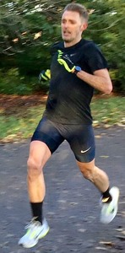

Parkruns continued to attract large numbers of Phoenix participants young and old, with multiple pbs set; Charlie Grice broke the course record at Hove Park in November with an amazing 14:25. http://www.brightonphoenix.org.uk/stories/604 Robbie Fitzgibbon followed this with a 14:31 record at Hove Prom in December which took him to the top of the All-Time national U23 rankings.
http://www.brightonphoenix.org.uk/stories/608
Finn McNally’s 2015 record of 14:47 at Preston Park remains intact, leaving Bevendean Down as the only local parkrun record left not held by a Phoenix runner - though Paul Whelpton staked a claim as the oldest winner of a local parkrun with his success at Bevendean in January 2018.

The Chichester 10k in February 2018 attracted a high-quality field, particularly as this year it doubled as the Sussex 10k County Championship, and as a qualifier for an Age-Group international 10k in Birmingham this May. Ross Skelton, Max Dumbrell and Donald Maclellan were 2nd team in the race and in the Sussex Champs, whilst Malcolm Kemp and Paul Whelpton retained their Sussex V70 and V60 10k titles, with Andrew Haig and Phil Hampshire both in second place behind them. And Malcolm Paul and Andrew all booked their places in the England team for Birmingham. http://www.brightonphoenix.org.uk/stories/618

SUSSEX GRAND PRIX
2017 saw a great step forward in the revival of our fortunes in the Sussex Grand Prix, an interclub competition made up of 17 road races across the county (with a bit of trail running thrown in.) After winning second place in the Vet Men’s title in 2014 with the minimum requirement of 5 regular participants, and the Men’s Open title in 2016 again with the bare minimum of 10 runners, 2017 saw a massive improvement. We got over 20 runners lining up for many of the races, and ended the season with 16 men and 7 women having completed the key target for scoring purposes of 8 races or more.

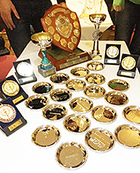
And we won the overall Grand Prix title for the first time this century, as well as claiming the Men’s Open and Vet Men’s titles by massive margins, and finishing as runners-up in the Women’s Open competition. We filled 5 of the top 10 places in the men’s Open competition (thus matching the combined performance of all 23 other clubs in the competition put together). In all we claimed 20 individual medals, including 11 age category medals, 4 of them gold, and with our medal winners ranging in age all the way from 17 to 71!
http://www.brightonphoenix.org.uk/stories/620

We were especially pleased at the team spirit that developed through the season and at the massive increase in participation by our women athletes. And it is a great indication of our strength in depth to note that this success was achieved with minimal involvement from our elite athletes whose other racing commitments, as in past years, made the minimum target of completing 8 SGP races too hard to meet.

The seventeen 2017 races:

Eastbourne Half Marathon - mainly seafront but with a tough climb early on up towards Beachy Head. http://www.brightonphoenix.org.uk/stories/554

Hastings Half Marathon* - many runners’ favourite Half, plenty of hills but surprisingly quick http://www.brightonphoenix.org.uk/stories/557

Haywards Heath 10 – a fine win for our Women’s Team on this tough mainly-trail race http://www.brightonphoenix.org.uk/stories/561

Hastings 5* - fast seafront race, won by Josh Guilmant i
Horsham 10k* - undulating country lanes, won by Max Dumbrell
Rye 10 – scenic and hilly country lanes
http://www.brightonphoenix.org.uk/stories/564

Worthing 10k – a fast and flat mainly seafront race
Heathfield 10k* - seriously hilly country lanes, and a win for our Men’s Team
Bewl 15* - a very pretty trail run around Bewl Water with a steep downhill stretch at the start and tough climb back up the hill at the end. Finishers in 2017 were greeted by the usual brassband, beer tent and cake stalls, as well as by Dame Kelly Holmes – though one or two of us managed to make it back to the finish ahead of her!

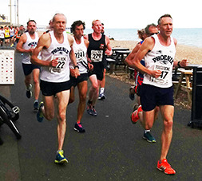

Phoenix 10k* - our very own fast and flat seafront race of course, great for bagging a pb, though the high-quality field makes it one of the harder Grand Prix races to score well at.
http://www.brightonphoenix.org.uk/stories/571

Bexhill 5k – fast (provided the wind is kind) seafront race
Newick 10k – more pretty hilly country lanes; 6 of the top 15 finishers had Phoenix vests on
http://www.brightonphoenix.org.uk/stories/583

Hellingly 10k* - relatively gentle hills on this one, and another team win for our Men
Barns Green Half Marathon – a very pretty route including Christ’s Hospital School, trail and country lanes; doubles as the County Half Marathon Championships
Lewes Downland 10* - many runners’ favourite, provided you like the Downs and are ready for the taxing climb up out of Ashcombe Bottom to Blackcap; another win for our Men’s team
Hove Prom 10k* - flat and quick of course, nicely organised by our rivals Arena 80. We loved the edible medals!
Crowborough 10k* - the last race of the season, on a two-lap road course featuring a ford followed by a monster climb. Wins on the day for our Men’s and Women’s teams, and we followed the race up with a Social at the Wick Inn where numbers were crunched to confirm our monster haul of medals and trophies, and Izzy Anderson (full set of 8 races completed whilst pregnant!) and Supervet Andrew Haig picked up their SGP Athlete of the Year awards http://www.brightonphoenix.org.uk/stories/606

For 2018 the format of the Grand Prix is being altered, with the total number of races being reduced to 10. (Races marked with an asterisk are those that will feature in 2018.) The minimum number of races needed to post a competitive score is going down from 8 to 6, and a new system of team scoring race by race will mean even those only able to do the occasional SGP race can contribute to our team score. Our aim has to be a fourth successive year of improvement - which means of course we need to up our game, recruit a few more participants – especially women runners - and target the Women’s Open title, the only major trophy to escape us in 2017!

TRACK AND FIELD
Another good year, with success at all levels right up to the international stage, though turnout in some of the junior age groups was lower than we would have wished. We retained our outstanding strength in depth in the middle-distance events, with 15 of our men, including 8 U20s, ducking under 2 minutes for 800m, and 5 of them also breaking the 1:50 barrier. And we had 12 men under 4 minutes for the 1500m, headed by Charlie Grice on 3:35.6 and Robbie Fitzgibbon with a big pb of 3:36.97. Charlie also earned selection for the 2018 England Commonwealth Games squad.
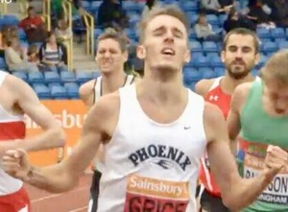

Alex Brothwell and Maia Hardman kicked off 2017 in fine form at the Southern Indoor Championships on 7th January, Alex finishing 1st in the U15 1500m and Maia 2nd in the U17 800.
On 12th February Spencer Thomas, Sophie Mansfield, Finley Bigg and Robbie Fitzgibbon all competed at the British Indoor Championships, with Spencer having the greatest success, clocking 1:49.12 to finish 3rd in the Men’s 800m A week later Jess Powell claimed double gold in the U13 Girls 60m and Long Jump at the Sussex Indoor County Championships.
http://www.brightonphoenix.org.uk/stories/547

Louisa Saunders, Ollie Johnson, Harry Swindells, Maia Hardman and Josh Eeles all put in excellent performances at the England U15/U17/U20 Indoor Championships in Sheffield on 25th February.

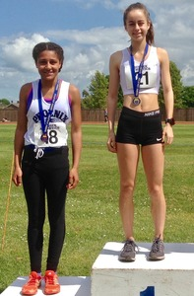

Moving outdoors the Sussex County Championships at the K2 in Crawley on 13th May saw many excellent performances, especially from our Juniors, and 11 of our athletes came away with medals.
http://www.brightonphoenix.org.uk/stories/563

Our annual Phoenix Open Meet at Withdean on 31st May attracted some outstanding athletes from other clubs as well as a big turnout from around 80 of our athletes across all the age groups. In an exceptionally high-quality 800m Spencer Thomas’s impressive 1:48.35 was only good enough to earn him 3rd place, whilst in the 1500m Josh Eeles fought his way to a fine victory in a pb of 3:54.41.

In June Finley Bigg finished 2nd in the U20 400m in the South of England Championships, and Maia Hardman, Dan Stidder, Leo Brewer and Almi Nerurkar all won titles at the Sussex Schools Championships. At the England U23/U20 Championships there were bronze medals for Robbie Fitzgibbon in the U23 1500m, and for Spencer Thomas in the U23 800m, whilst Toby Harries finished 2nd in the U20 800m.
On 2nd July seven of our athletes featured in the British Athletics Championships, though after the Olympic heights of 2016 the size of this achievement was rather overlooked in the disappointment that our best placing was Charlie Grice’s 5th in the 1500m. Two weeks later Robbie Fitzgibbon made it through to the final of the 1500m in the European U23 Championships in Poland.

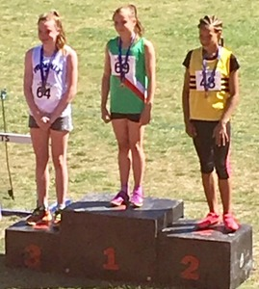
The U13 Sussex Championships on 9th July saw some good performances from our junior athletes, notably a bronze medal for Keira Patterson-Jewell in the Girls 150m. http://www.brightonphoenix.org.uk/stories/576

On the same day Charlie Grice and Robbie Fitzgibbon featured in a thrilling 1500m race in the Anniversary Games http://www.brightonphoenix.org.uk/stories/570

Highlight of the year on 22nd July came at the European U20 Championships in Grosetto, Italy, where Toby Harries clocked 20.81 to win the final of the 200m. Archie Davis also came close to a medal, finishing 5th in a slow tactical 1500m.
http://www.brightonphoenix.org.uk/stories/577

In August Louisa Saunders won herself a bronze medal, and a pb of 57.77, in the U17 Girls 400m at Crystal Palace in the South of England U15/U17 Championships.

Beth Kidger continued her great form into January 2018, setting a pb of 4:29.27 as she won herself another Welsh national title in the 1500m at the Welsh Indoor Senior Championships in Cardiff.

MULTISPORT
Multisport remains the main focus of a sizeable proportion of our members, who continued to produce a stream of impressive results through 2017.

The season began with The Frosty Aquathlon in March where Sam Wade claimed overall gold and Malcolm Hughes was the first Vet. http://www.brightonphoenix.org.uk/stories/553

Erica Martin finished 3rd in her age category at the British Duathlon championships on 9th April. http://www.brightonphoenix.org.uk/stories/559 This gained her a place at the European Duathlon Championships in Soria three weeks later where she finished in an excellent 5th place.

In June Malcolm Hughes finished 2nd in his age category at the British Age Group Triathlon Championships, and went on to compete in the European Championships one week later, finishing 16th. June also saw some of our younger athletes give multisports a try out at the Brighton Multisport Kids’ Aquathlon

Competing for Team Pedalcover in June Sam Wade was the only athlete to break the one-hour barrier as he claimed the Sprint Distance England National Triathlon title at Thorpe Park. On 1st July the England Triathlon Championships in Ripon brought more success for Sam Wade who was 2nd overall and Malcolm Hughes who was 3rd in his age category.
http://www.brightonphoenix.org.uk/stories/573

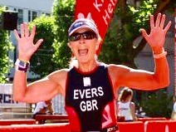
Iron Men and Women: In June Deb Evers travelled to Germany for the Heilbronn Challenge – a mere seven-hours of pain over a half-distance, but seriously hilly course! http://www.brightonphoenix.org.uk/stories/586
Tom Sanderson joined our select band in July, completing his first Ironman at Bolton in a very respectable 12:40. http://www.brightonphoenix.org.uk/stories/596

And in September Geoff Pike donned his GB suit for the European Ironman Distance Championships at Almere/Amsterdam, where he was 15th in his age category and broke the 11-hour barrier, crossing the line in 10:54. http://www.brightonphoenix.org.uk/stories/587

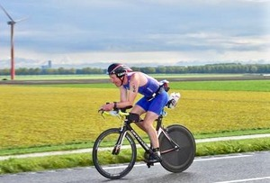

Unsurprisingly it was the Brighton Triathlon in September that produced the club’s biggest turnout of the season with10 members taking part, including youngsters Ella Baum and Marnie Butler in the age 9-10 race. And we came away with four age category wins and two third places. On the same day in the ITU World Championships in Rotterdam Sam Wade finished 2nd in his 25-29 age category just 12 seconds behind the winner, and Malcolm Hughes came home 38th in the 55-59 age group. http://www.brightonphoenix.org.uk/stories/590

The club Multisports Championships – based on results in five local events – saw victories for Mark Walker as well as for our club captain Bobby Searle, a relative newcomer to multisport.

SOUTH DOWNS WAY RELAY

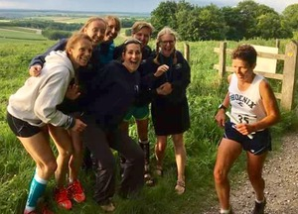
This race at the beginning of June is always a highlight of the year for those lucky or crazy enough to enjoy running three races in the same day and spending their recovery periods cramped up in a speeding minibus with five other progressively-sweatier runners and a long-suffering driver. In 2017 six of our elite athletes made it into the race as a special A+Phoenix Honeybadgers team, and would undoubtedly have broken the course record if they had all done their homework and reccied their legs thoroughly beforehand. (Mobile phones appeared from time to time as navigational aids.) As it was they finished four minutes behind winners Stubbington Green, though still clocked a very impressive 10 hours 22 minutes. Numerous club leg records tumbled during the course of the day, and our Women’s team finished in 13:17:23, a club record for the new course, though they lost out in their nip and tuck tussle with our B team who eventually finished 15 minutes ahead of them. Our A Team also suffered from some navigational hiccups but still finished in a respectable 11:33. http://www.brightonphoenix.org.uk/stories/566
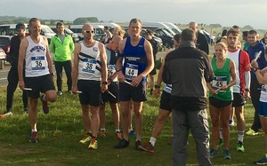

SPORTSHALL
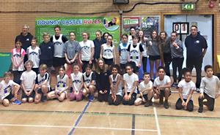

Our younger athletes continued to compete in the Worthing Sportshall League against three other local clubs. Turnout is as important as finishing position in these events, which are valuable training sessions as well as an introduction to competition in an indoor setting which has particular appeal to parents/spectators as well as to young athletes in midwinter!
The 2016/17 Sportshall season was a great success with an excellent turnout from our youngsters and many fine performances. The final match of the 2016/17 season on February 25th 2017 saw us reach a total of 516.5 points and finish in second place, behind Worthing & District Harriers who totalled 622 points, and ahead of Lewes (383 points) and Burgess Hill (190 points).
The 2017/18 season has produced even better results, with Phoenix emerging as winners by a whisker in both of the first two fixtures (after an initial error in the scoring for the first match was corrected). http://www.brightonphoenix.org.uk/stories/609
Our main rivals have once again been Worthing, and our winning margins over them were just 3.5 points in the first match on December 9th 2017 (229 to 225.5), and an even closer 2 points in the January 2018 fixture (229 to 227). So we headed to the third and final fixture in February 2017 with all to play for and a slender lead of 5.5 points.
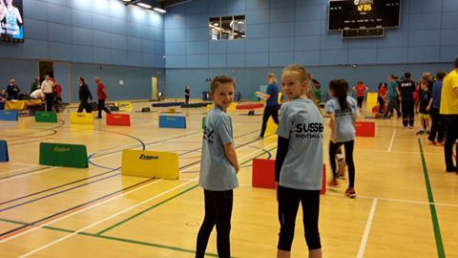Too many fine individual performances to list them all but special congratulations to Kira Betts, Angelina Bowen and Rosa Howie who competed for Sussex in the Sportshall Fun In Athletics Regional Final on February 10th 2018
Credit is due not just to our athletes but also to coach Roy Hayward and his team of assistants - notably Paula Bowen, Steve Hardman and club chairman Mike Townley - as well as to the many other parents who have helped out in various ways as well as coming along to cheer our athletes on at the events.

